 | ANGLO-CHINESE JUNIOR COLLEGE  JC2 Preliminary Examination  Higher 2

GEOGRAPHY |  | 9173/02

Paper 2

Marking Scheme

&

Suggested Answers

Section A

Cluster 4 Fieldwork

Question | Answer | Marks
1(a) | Explain one strength and one weakness of the research question for the students’ investigation.  Award 1 mark for each explanation one strength and one weakness of the research question.  Award a maximum of 1 additional mark for further development of each explanation, where applicable.  Award a maximum of 2 marks for explanation of either strength or weakness only.  Possible responses include:  Strength  - It is at a suitable scale as the investigation is confined within Tengah. [1] The scale of investigation is suitable to 6 students. [1 additional mark]  - There are two variables identified, the independent variable is the availability of EV charging infrastructure in influencing community responses towards EV adoption, which is the dependent variable. [1]  - It is researchable because it is possible for students to collect the required data about the residents’ perception through survey. [1]  Limitation  - The term ‘community’ is somewhat broad and vague in the context of the research question. [1] Specifying a particular group of people within the Tengah area can help narrow the focus and make the research more targeted, e.g. car owners, working adults. [1 additional mark]  - The term ‘influence’ is a subjective term. [1] The understanding of this term can be interpreted differently by different respondents. [1 additional mark] | 4
1(b) | Suggest how the students could minimise potential risks while conducting the questionnaire at the sites shown in Resources 1 and 2.  Award 1 mark for each explanation of how the students could minimize potential risks when visiting the two sites, to a maximum of 5 marks.  Award a maximum of 1 additional mark for further development of each explanation, where applicable.  Possible responses include:  - There may be a risk of traffic accidents when crossing in the carparks during fieldwork. [1 mark] Students should follow road safety rules, look out for vehicular traffic and use pedestrian paths or crosswalks where possible. [1 additional mark]  - Students should wear brightly coloured shirts to enhance their visibility to drivers and reduce the risk of accidents in the carpark. [1 mark]  - Students should maintain a safe distance from the carpark railings to minimise the risk of falling. [1 mark]  - Students could ensure that they are in cooling and comfortable attire / bring water bottle, [1 mark] This will reduce the chances of getting dehydrated due to a relatively enclosed carpark space. [1 additional mark]  - Students should carry first-aid kits [1 mark] to minimise physical risk and injuries and ensure rapid response in emergencies [1 additional mark]  - Students should conduct fieldwork in pairs rather than alone so that they can look out for each other [1] and provide immediate assistance if one of them encounters an accident or injury. [1 additional mark] | 5
1(c) | Explain three ethical considerations that the students should take into account when conducting their questionnaire survey.  Award 1 mark for each explanation point of ethical considerations the group should take.  Award 1 additional mark for further elaboration of each point.  Possible responses include:  - Students should obtain informed consent from survey respondents before conducting the surveys. [1] Make sure to explain the purpose of the investigation and ensure that participation is voluntary. [1 additional mark]  - To inform the respondents the data collected will only be used for this research to ensure data privacy. [1 mark] Data should be anonymised to protect the identities of the respondents. [1 additional mark]  - Ensure confidentiality of data collected. [1] Inform respondents that their anonymity will be maintained and they will not be able to be identified. [1 additional mark]  - Before the conducting the survey, students are to seek permission from local authorities for conduct of research (e.g. Tengah Town Council). [1]  - Respondents must be given the autonomy to decide that they might not want to continue with the survey at any point in time should they feel uncomfortable [1]  - Need for vetting and thinking through of questions. [1] To ensure questions are not sensitive and would not unintentionally cause discomfort to the survey respondents. [1 additional mark]  - Invasion of Privacy: Collecting data in could lead to privacy concerns if photos are taken without consent. [1] Ask permission from respondents before taking any photo. [1 additional mark] | 6
1(d) | Explain the strengths and weaknesses of the questionnaire shown in Resource 3.  Award 1 mark for each explanation of a strength or a weakness.  Award a maximum of 1 additional mark for further development of each explanation. Award a maximum of 3 marks for explanation of either strengths or weaknesses only.  Possible responses include:  Strength  - The sensitivity of the request for age group of 20-39, 40-59 and 60 and above, rather than specific age of participants [1] which respondents may not want to divulge and may also be easier in capturing the opinions of different groups [1 additional mark]  - The simplicity of the tick box format which makes it easy for the respondents to fill it out. [1]  - The questions are relevant and cover a range of aspects that include challenges of driving EV, availability of EV charging stations and cutting carbon emissions. [1] They cover very specifically a range of factors to assess whether availability of EV infrastructure influence community responses so as to address their research question. [1 additional mark]  Weakness  - The broad “60 and above” age category includes people approaching retirement as well as those who have been retired for many years. [1] These groups may have different driving habits, financial circumstances and perceptions of EV adoption. Grouping them together may therefore mask differences within the age group and reduce the validity of conclusions drawn from the survey results. [1 additional mark]  - Only close-ended questions are used in the survey and this limits the amount of detailed information collected. [1] This prevent respondents from expressing reasons, concerns or opinions that were not included among the available choices. As a result, the survey may provide less insight into why respondents have particular perceptions of EV adoption. [1 additional mark] | 6
1(e) | Using Resource 4, sketch a suitable method to represent the data on EV owners’ responses to Question 7. Justify your choice of method.  Award maximum 4 marks for drawing of a suitable data representation method.  Award 1 mark each for;  - Title  - Axis  - Legend/Labelling of each bar graph / segment  - Proportions of bar graphs / pie chart (accuracy)  Award 1 mark for justification on choice of data representation method.  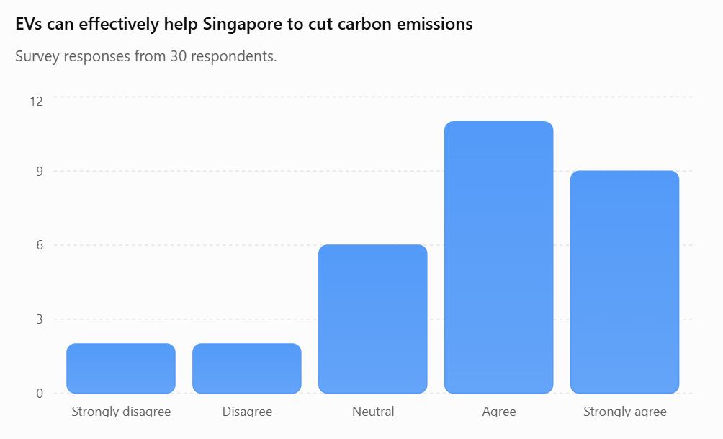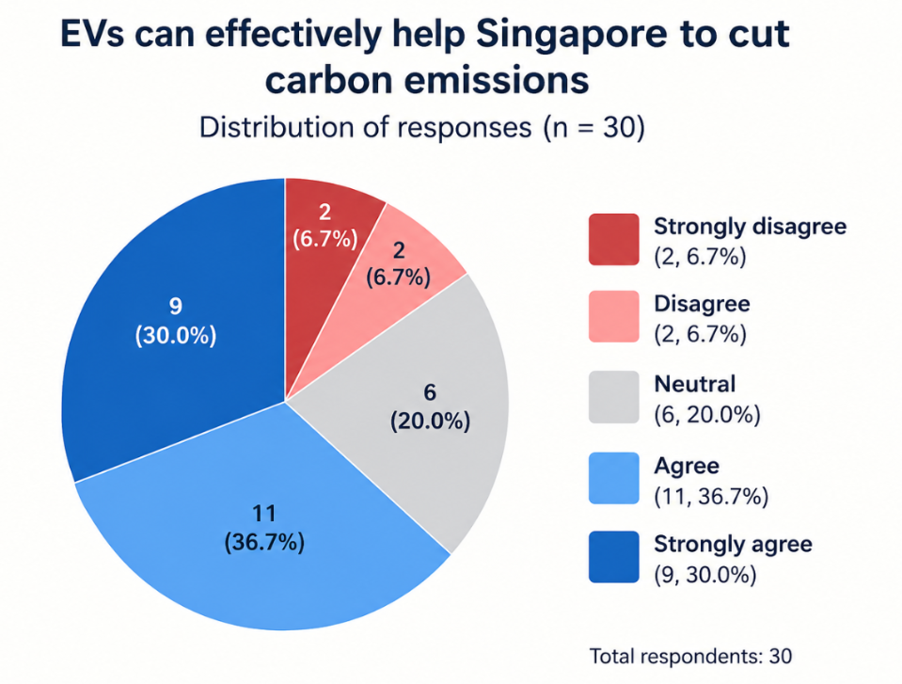  Justification:  - A bar graph helps to present multiple data sets in 1 graph sharing the same axes. This allows easy comparison of data sets across the 5 different responses.  - OR  - A pie chart is appropriate because the responses represent different proportions of the total number of respondents. It clearly shows the relative share of respondents selecting each response and allows the most common response to be easily identified. | 5
1(f) | Suggest two other types of primary data that could be collected to complement the questionnaire findings in answering the research question.  Award 1 mark for each explanation of a type of primary data that could be collected.  Award a maximum of 1 additional mark for further development of each explanation.  1. Field observations of EV charging stations  Students could conduct systematic observations at several EV charging stations in Tengah, recording:  - number of charging bays  - number of vehicles using the charging stations at different times  Why useful: This provides actual evidence of the availability and accessibility of charging infrastructure, which can then be compared with questionnaire responses about how difficult respondents find it to locate an available charging point.  2. Socioeconomic Data  Knowing the education qualification, income and household income will also help to determine if the other factors influence the response towards EV adoption.  - Education Level, and Income: Data on the residents' education levels, and income brackets can help provide insights into other variables that might influence EV adoption and climate change awareness.  3. Access to Information: Information on the types of media consumed by respondents, such as newspaper readership, internet usage, or social media engagement, which can influence their awareness of EV adoption, e.g. the knowledge of government policies.  4. Interviews with EV owners / potential EV adopters  Students could conduct short semi-structured interviews asking respondents to explain how the availability of charging infrastructure affected their decision to purchase or consider purchasing an EV.  For example:  - Was access to charging facilities an important consideration?  - Would better charging availability make them more likely to adopt an EV?  - Have they experienced difficulties finding or using charging points? | 4
1(g) | Using all the Resources, evaluate the validity of the students’ fieldwork.  Possible Approaches include:  Candidates could evaluate the investigation by reviewing the methods used to collect data and the data collected in Resource 4. Candidates could review the data collection method, the questionnaire used, and assess the impact on accuracy and reliability of data collected. Evaluation of these methods could include looking at the sample size, whether the samples selected are representative of the resident population in Tengah, the range of two sites as seen in Resources 1 and 2, strengths and weaknesses of the different methods, etc.  Candidates could consider the accuracy and reliability of the survey questionnaire. The students are assuming that driving EV is an environmentally friendly behaviour that can possibly be a direct indication of greater climate change awareness. However, behaviors can be influenced by various factors such as economic constraints, lifestyle preferences, or infrastructure availability, which might not necessarily reflect a resident’s awareness of climate change. The survey questions do not directly assess respondents’ knowledge or attitudes about climate change. Therefore, concluding better climate change awareness based on these behaviors alone is speculative without more direct measures of awareness and may cause the fieldwork to be invalid.  Levels marked using Generic Level Descriptors for H2 fieldwork evaluative questions.  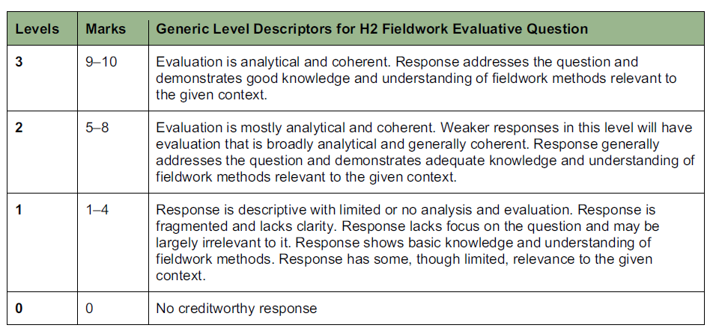 | 10

Section B

Cluster 3: Sustainable Future and Climate Change

Question | Answer | Marks
2(a) | With reference to Resource 5, explain two anthropogenic causes of contemporary climate change.  Award 1 mark for identiﬁcation of each anthropogenic cause with reference to Resource 5.  Award a maximum of 2 additional marks for further development/explanation of each cause.  Award a maximum of 3 marks for explanation of one cause only.  Possible responses include:  - Resource 5 shows that consumption-based CO₂ emissions per capita rise sharply as GDP per capita increases, with high-income countries such as Singapore, Qatar and the United States recording the highest emissions [1 mark].  - This reﬂects greater combustion of fossil fuels for electricity generation, industrial activity and private transport as affluence and consumption of energy-intensive goods and services increase [1 additional mark].  - Wealthier populations also own more vehicles and appliances and consume more energy per household, further increasing fossil fuel combustion [1 additional mark].  - Resource 5 measures consumption-based emissions, which account for emissions embedded in imports. This shows how demand for manufactured goods in high-GDP countries drives industrial production (often reliant on fossil fuels such as coal) in exporting/manufacturing countries, e.g. China, transferring emissions generation to lower-GDP countries while consumption occurs in richer countries [1 mark].  - This reﬂects how globalised trade and production networks are a human/anthropogenic driver of greenhouse gas emissions [1 additional mark].  - A second anthropogenic reason for contemporary climate change is that of loss of carbon sink through land use change, in particular, that of deforestation When forests are removed to provide land for agriculture, industrial and urban land use, the carbon is lost and the allows for less carbon dioxide to be withdrawn from the atmosphere [1 mark].  - South America and South Asia (like India, Pakistan and Bangladesh) are examples of location with lower contribution to greenhouse gas emission [1 additional mark]. | 5
2(b) | Compare the temperature changes in the Arctic and the tropics between 2000 and 2025 shown in Resource 6  Award 1 mark for each comparison, to a maximum of 4 marks.  Award a maximum of 1 additional mark for further development of each comparison, where applicable.  Possible responses include:  Similarities:  - Both regions show an overall warming trend from 2000 to 2025, with temperature anomalies shifting from being close to/below 0.0°C in the early 2000s to positive anomalies by the 2020s [1 mark].  Differences:  - The Arctic experienced a much greater magnitude of warming than the tropics [1 mark]. By the early-to-mid 2020s, Arctic anomalies exceed 1.0 °C in several years, whereas tropical anomalies remain below about 0.5–0.6 °C over the same period [1 additional mark].  - The Arctic shows more year-to-year variability/ﬂuctuation in temperature anomalies, while the tropics show a more gradual and steady increase [1 mark].  - The Arctic crossed into a sustained positive anomaly earlier (around the mid-2000s) compared to the tropics, which only show consistently positive anomalies from around the mid-2010s [1 mark]. | 4
2(c) | Describe two climate feedback mechanisms that contribute to the observed patterns of temperature changes shown in Resource 6.  Award 1 mark for each description of a relevant feedback mechanism, to a maximum of 2 marks for each.  Award a maximum of 1 additional mark for further development of each description, where applicable.  Possible responses include:  - Ice–albedo feedback: rising temperatures cause Arctic sea ice and snow cover to melt, reducing the surface albedo (reﬂectivity) [1 mark]. This exposes darker ocean/land surfaces which absorb more incoming solar radiation, causing further warming and more ice melt, explaining why the Arctic shows disproportionately larger warming (Arctic ampliﬁcation) than the tropics [1 additional mark].  - Water vapour feedback: as global temperatures rise, evaporation increases and warmer air holds more water vapour, which is itself a greenhouse gas [1 mark]. This traps additional outgoing longwave radiation, amplifying warming, and is particularly signiﬁcant in the warm, moist tropical atmosphere [1 additional mark].  - Permafrost–carbon feedback: rising Arctic temperatures cause permafrost to thaw, releasing stored carbon dioxide and methane into the atmosphere [1 mark]. This enhances the greenhouse effect and reinforces further warming in the Arctic region [1 additional mark]. | 4
2(d) | Explain the challenges faced when making predictions of future impacts of contemporary climate change.  Award 1 mark for each explanation of a challenge, to a maximum of 6 marks. Award a maximum of 1 additional mark for further development of each explanation, where applicable.  Possible responses include:  - The climate system is highly complex, involving multiple interacting positive and negative feedback loops (e.g. ice–albedo, water vapour, carbon cycle feedbacks) [1 mark]. The uncertain strength and timing of these feedbacks make it difficult for climate models to precisely project the magnitude of future impacts [1 additional mark].  - Future emissions trajectories depend on unpredictable human factors such as government policies, technological innovation, and economic growth patterns [1 mark]. This is why climate models rely on multiple divergent scenarios/pathways rather than a single prediction, creating a wide range of possible future impacts [1 additional mark].  - Global Climate/General Circulation Models (GCMs) operate at coarse spatial resolutions [1 mark], making it difficult to accurately downscale projections to predict localised impacts, such as impacts on speciﬁc cities or ecosystems [1 additional mark].  - There is uncertainty over climatic tipping points and thresholds (e.g. collapse of ice sheets, dieback of the Amazon rainforest) [1 mark]. Once triggered, these could lead to abrupt, non-linear and potentially irreversible changes that are very difficult to predict using existing models based on historical trends [1 additional mark].  - Historical climate data is incomplete or unreliable in some regions, particularly in developing countries with limited monitoring infrastructure [1 mark], reducing the accuracy of baseline data used for future projections [1 additional mark]. In addition, countries at times underreport their current GHG emission (believed to be between 8.5 to 13.3 billion tonnes).  - Climate change interacts with other non-climatic stressors such as land use change, pollution and population growth [1 mark], making it difficult to isolate and predict impacts attributable to climate change alone [1 additional mark]. | 6
2(e) | With reference to Resource 7, explain how climate change impacts vary across different groups of people.  Award 1 mark for each explanation of how impacts vary across groups, with reference to Resource 7, to a maximum of 7 marks.  Award a maximum of 2 additional marks for further development of each explanation, where applicable.  Possible responses include:  - Impacts vary by life stage/age. Children are more vulnerable to health outcomes such as increased infant mortality, malnutrition and respiratory diseases from climate hazards like rising temperatures and air pollution [1 mark], as they are still physiologically developing and depend on caregivers, and disruptions (e.g. from disasters) also affect their learning and access to education [1 additional mark]. In contrast, the elderly (later adulthood) face increased mortality, cognitive decline and heart/kidney disease [1 mark], partly because reduced mobility and existing comorbidities lower their resilience and reduce their access to health services during hazards such as heatwaves [1 additional mark].  - Gender-related vulnerability: adolescent girls face heightened risk of child marriage as a result of climate-induced displacement and migration [1 mark], showing how climate impacts intersect with existing gender inequalities to disproportionately affect certain groups [1 additional mark].  - Gender & age: Pregnant women face speciﬁc impacts such as stillbirth, preterm birth and gestational diabetes [1 mark], because heat stress and climate-related nutritional stress during pregnancy directly affect maternal and foetal physiology in ways that do not apply to other groups [1 additional mark].  - Impacts vary by socio-economic status. Lower-income groups have reduced access to health services and fewer resources to adapt (e.g. cooling, relocation, healthcare) [1 mark], as reﬂected in the "socio-economic factors" vulnerability listed in Resource 7, meaning they experience more severe consequences from the same climate hazard compared to wealthier groups [1 additional mark].  - Impacts vary geographically. Populations in low-lying coastal areas are more exposed to sea level rise and salination, threatening livelihoods and human rights [1 mark], while populations elsewhere may be more exposed to hazards such as disasters (ﬂoods/droughts/windstorms/wildﬁres) or rising temperatures depending on location [1 additional mark].  - Resource 7 highlights "intersecting inequalities" as a vulnerability factor, showing that individuals who belong to multiple at-risk categories simultaneously (e.g. poor, elderly women in coastal slums) face compounded and more severe climate change impacts than those with only a single risk factor [1 mark]. | 7
2(f) | Suggest two strategies that cities can use to improve the lives of slum dwellers.  Award 1 mark for each strategy suggested, to a maximum of 4 marks.  Award a maximum of 1 additional mark for further development of each strategy, where applicable.  Award a maximum of 2 marks for one strategy only.  Possible responses include:  - In-situ slum upgrading, where cities provide/improve basic infrastructure and services such as piped water, sanitation and waste collection directly within existing slum settlements [1 mark]. This is preferable to eviction/resettlement as it improves living conditions while minimising disruption to residents' existing livelihoods and social networks [1 additional mark].  - Participatory/community-based upgrading programmes that involve slum dwellers in the planning and decision-making process [1 mark]. This ensures that strategies address the actual needs of residents and foster a sense of ownership, increasing the likelihood of long-term success and maintenance of improvements [1 additional mark].  - Provision of secure land tenure or affordable/social/public housing schemes [1 mark], giving slum dwellers legal recognition and incentive to invest in improving their own homes and communities [1 additional mark].  - Microﬁnance schemes providing small loans/credit to slum dwellers [1 mark], enabling them to start small businesses or improve housing, thereby improving household income and living standards [1 additional mark]. | 4

Section C

Cluster 3: Sustainable Future and Climate Change

Question | Answer | Marks
3 | “Partnerships between the different actors are more important than the actions of any single actor in responding effectively to climate change.” Evaluate this statement.  Possible Approaches:  Candidates could approach the question by making a judgement on whether partnerships between different actors are more important than the actions of any single actor through a consideration of the relative contributions of states, firms and non-governmental organisations. Candidates could analyse how partnerships combine finance, regulatory authority, technology and local knowledge to address the causes and impacts of climate change. Candidates could evaluate whether such cooperation extends the reach and effectiveness of responses beyond what one actor could achieve.  Candidates could also approach the question by making a judgement on whether partnerships are more important in some contexts than others through a consideration of two or more case studies. Candidates could analyse contextual factors such as the scale of the response, national economic capacity, political commitment and the participation of vulnerable communities. Candidates could compare the outcomes of partnerships with state-led or firm-led measures and evaluate whether cooperation produces sustained and measurable results.  Levels marked using Generic Level Descriptors for 20m H2 essays  AO3 | 20
4 | Evaluate the success of strategies used to manage non-hazardous solid waste in urban areas.  Possible Approaches:  Candidates could approach the question by making a judgement on whether strategies used to manage non-hazardous solid waste in urban areas have been successful through a consideration of two or more case studies. Candidates could evaluate whether strategies have met their aims of reducing waste, recovering useful materials and disposing of residual waste safely. Candidates could also analyse contextual factors such as financial resources, collection coverage, waste composition and public participation, which may contribute to differences in success.  Candidates could also approach the question by making a judgement on whether some strategies have been more successful than others through a consideration of criteria such as long-term waste reduction, environmental protection, affordability and social equity. Candidates could compare reduction, reuse and recycling with incineration and landfill. Candidates could analyse the limits of each strategy, including the continuing need to dispose of residual waste, and assess whether a combination of strategies is more successful in different urban contexts.  Levels marked using Generic Level Descriptors for 20m H2 essays  AO3 | 20

